**Project Design Phase-I**

**Solution Architecture**

|  |  |
| --- | --- |
| Date | 16 September 2022 |
| Team ID | PNT2022TMID29695 |
| Project Name | Project – Visualizing and Predicting Heart Diseases with an Interactive Dash Board |
| Maximum Marks | 4 Marks |

**SOLUTION ARCHITECTURE:**

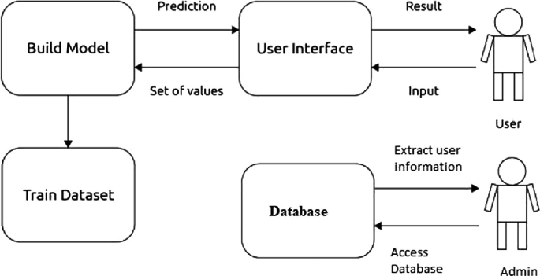

***Fig. SOLUTION ARCHITECTURE to demonstrate the solution using Machine Learning as UI MODEL***